***Analysing housing prices in Metropolitan Areas of India.***

**I. INTRODUCTION**

**1.1. Overview :**

Analyzing housing prices in metropolitan areas of India can be a complex task. To get started, you'll need access to housing price data, which can typically be obtained from real estate websites, government sources, or research organizations. Here's a general outline of steps to follow:

Keep in mind that the housing market is influenced by various economic, social, and geographic factors, so a thorough analysis is essential. Additionally, staying up-to-date with the latest data and market trends is crucial for accurate analysis.

* 1. **Purpose :**

Data Collection:

Gather housing price data for the desired metropolitan areas in India. This should include information on property type, location, size, number of bedrooms, amenities, and prices.

Data Pre - processing:

Clean the data by handling missing values, outliers, and inconsistencies. Convert categorical data (like property type) into numerical values through encoding techniques.

Exploratory Data Analysis (EDA):

Perform data visualization to understand trends and patterns in housing prices. Calculate summary statistics and correlations to gain insights.

**2. Problem Definition & Design Thinking :**

**2.1. Empathy Map :**

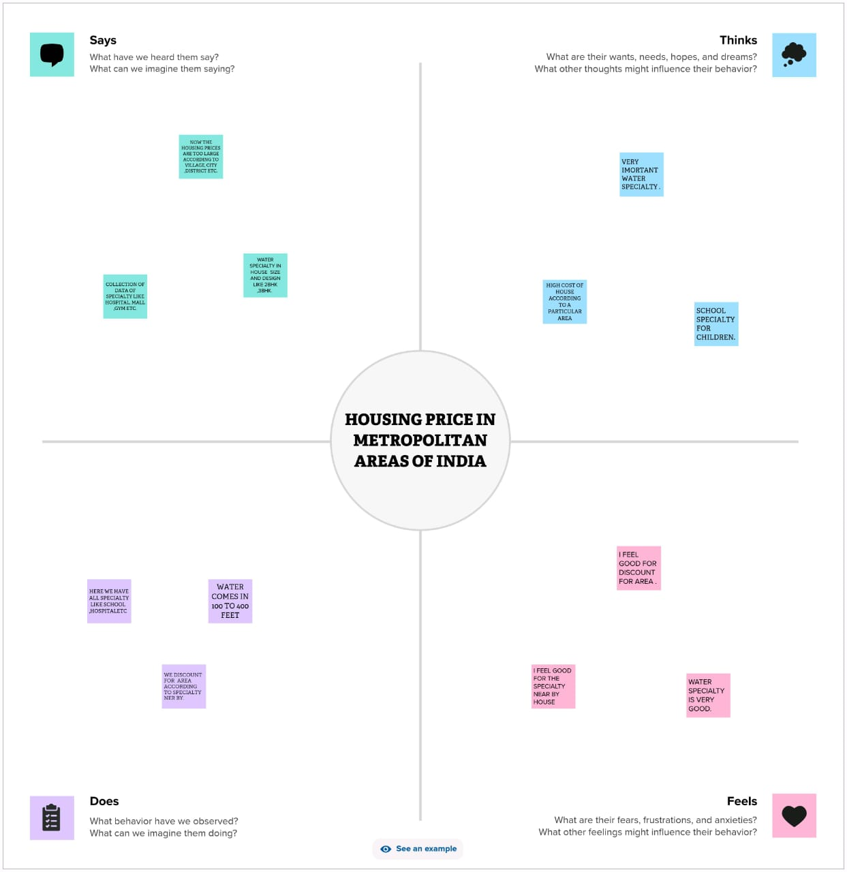

**2.2. Ideation & Brainstorming Map :**

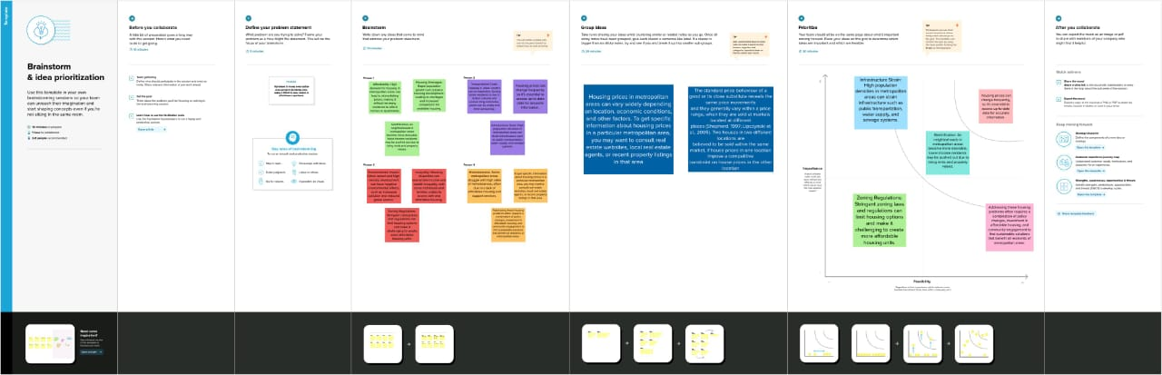

**3. RESULT :**

**Sheet 1 :**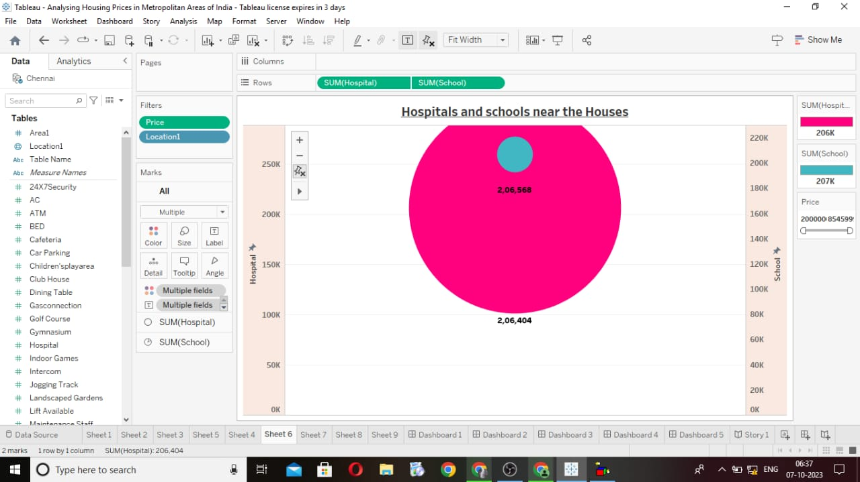

**Sheet 2 :**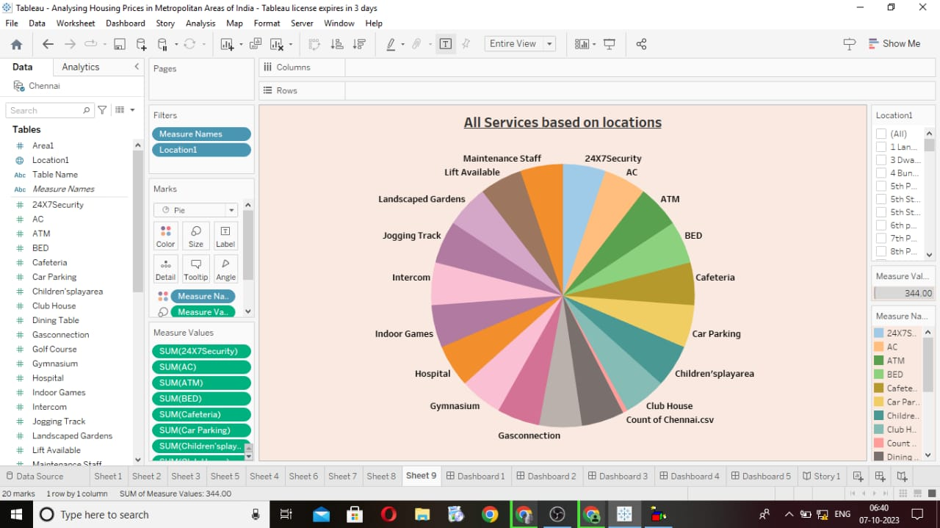

**Sheet 3: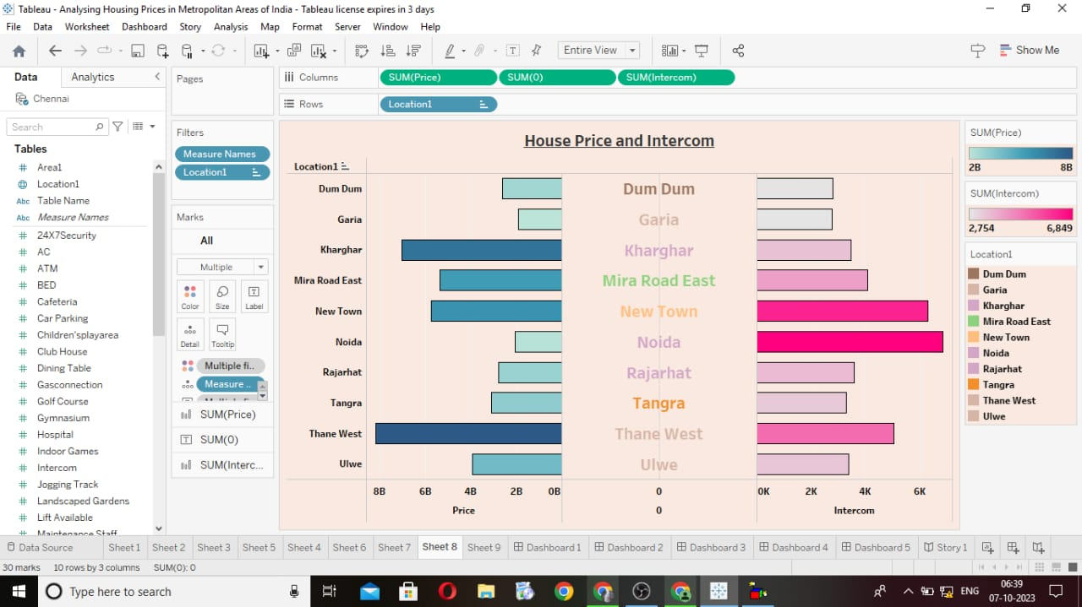Sheet 4 :**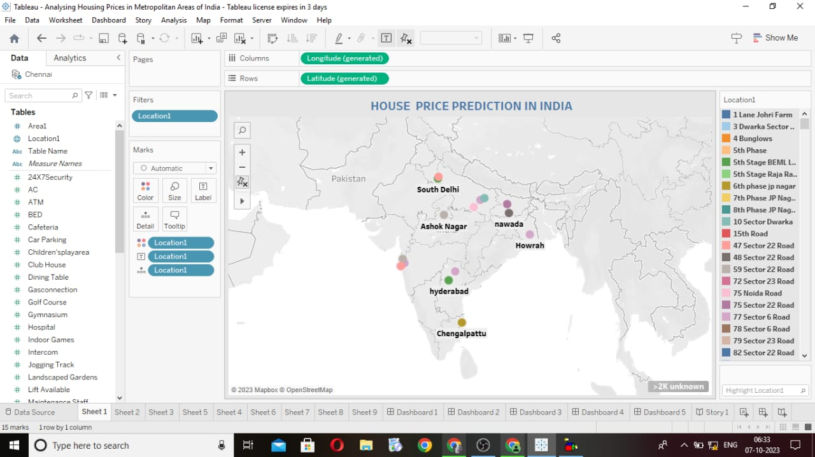

**Sheet 5:**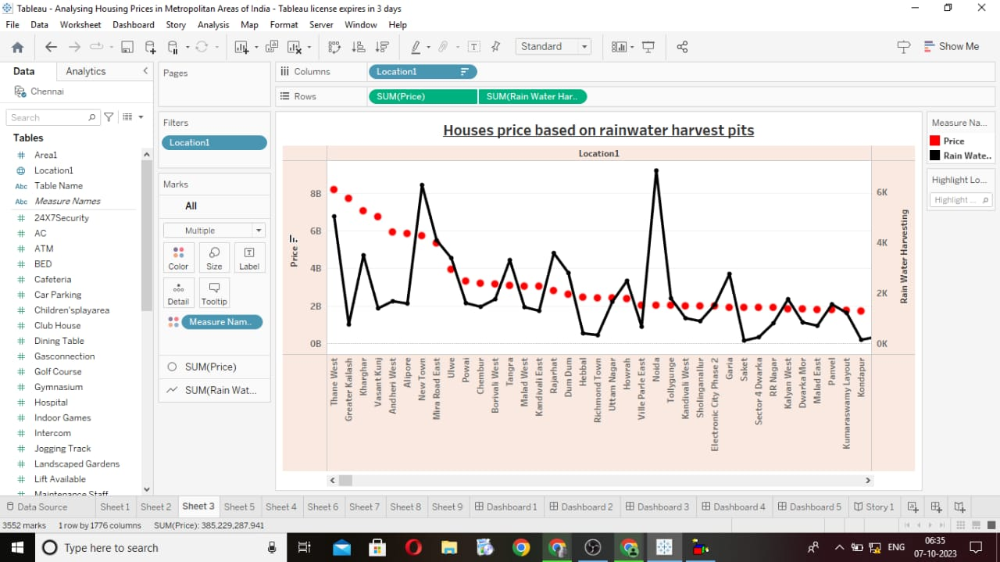

**Sheet 6 :**

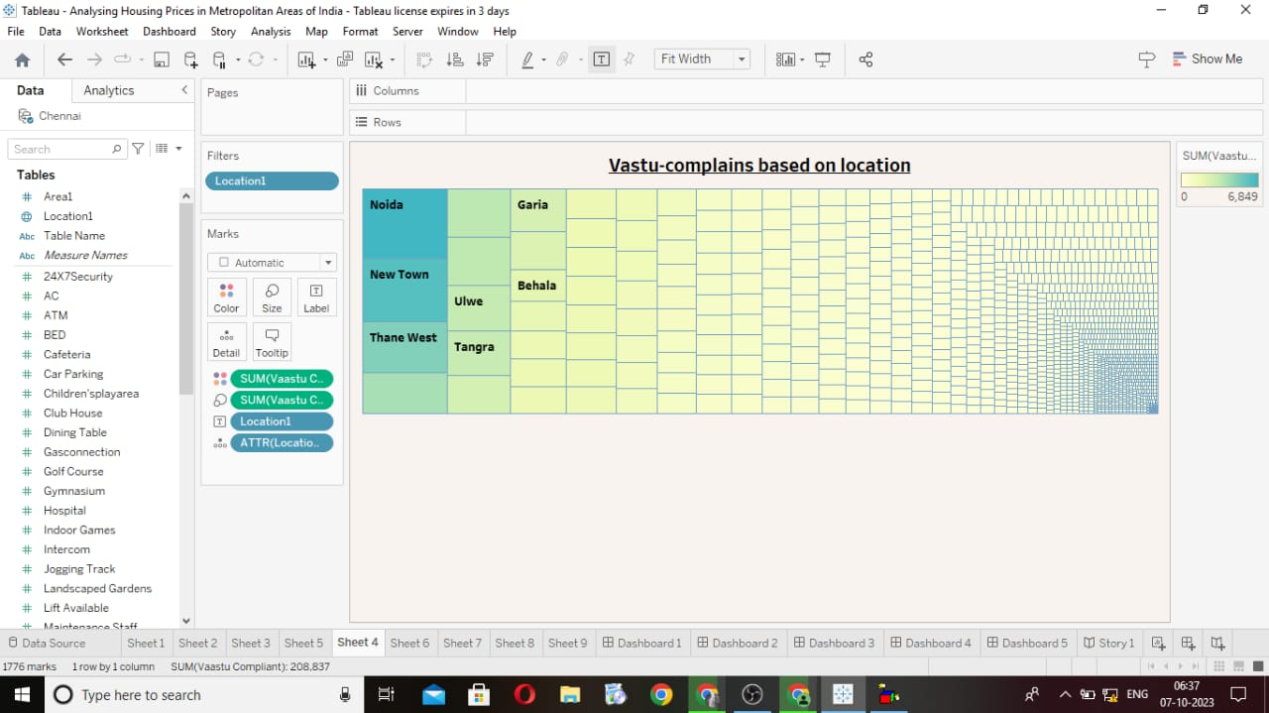

**Sheet 7 :**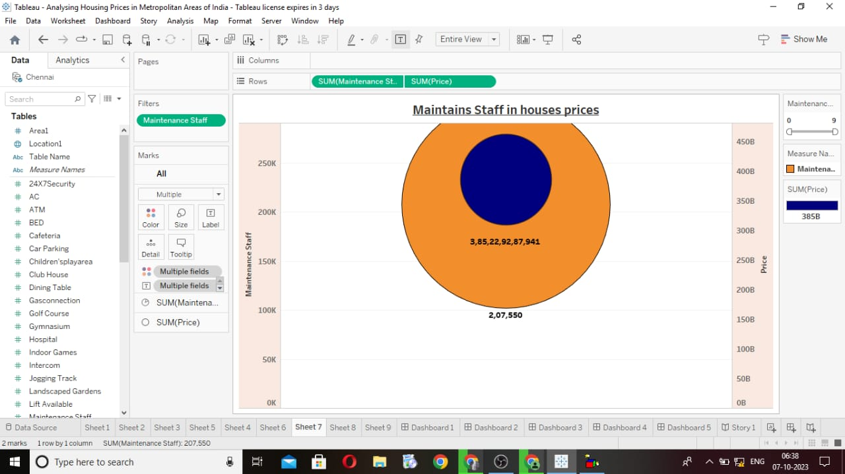

**Sheet 8 :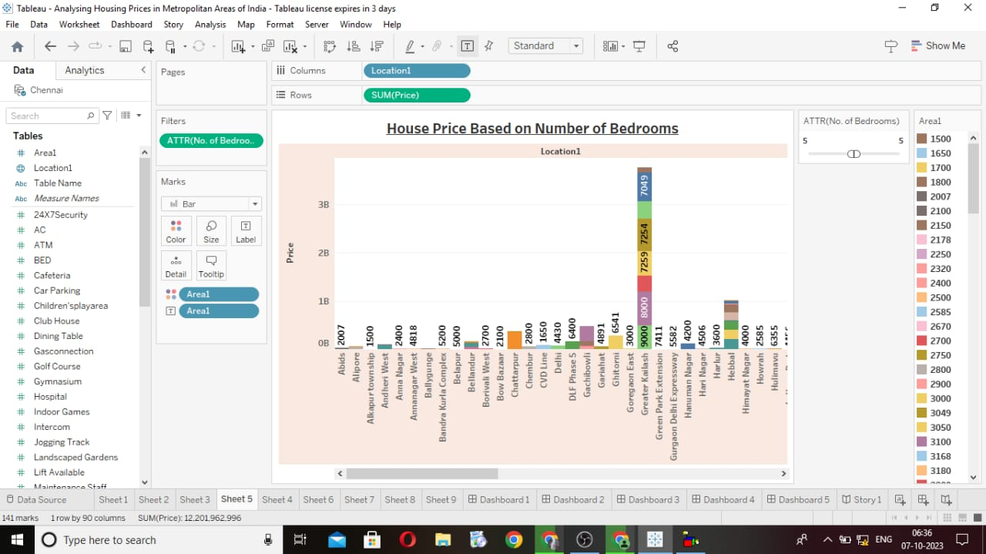Dashboard 1 :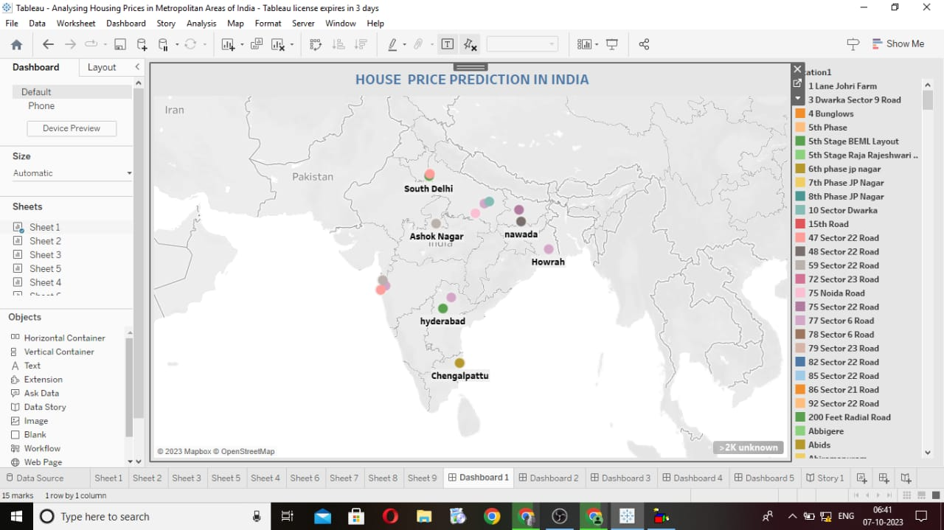Dashboard 2 :**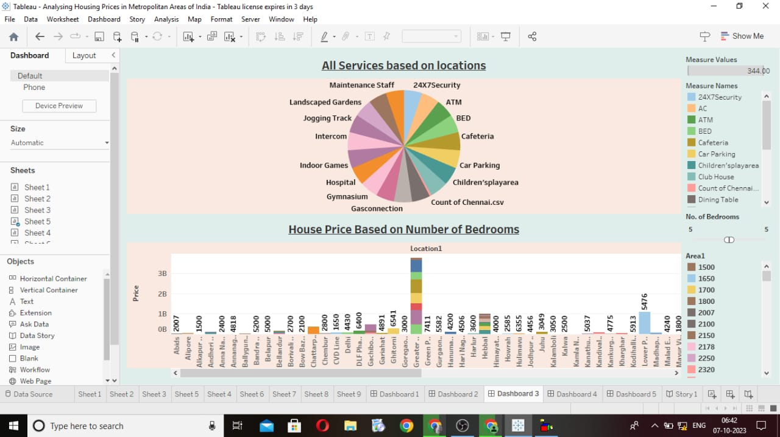

**Dashboard 3 :**

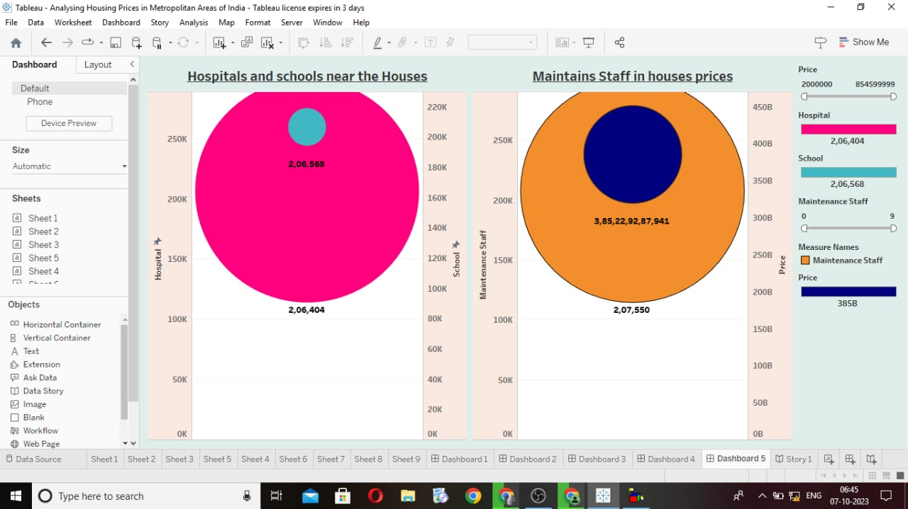

**Dashboard 4 :**

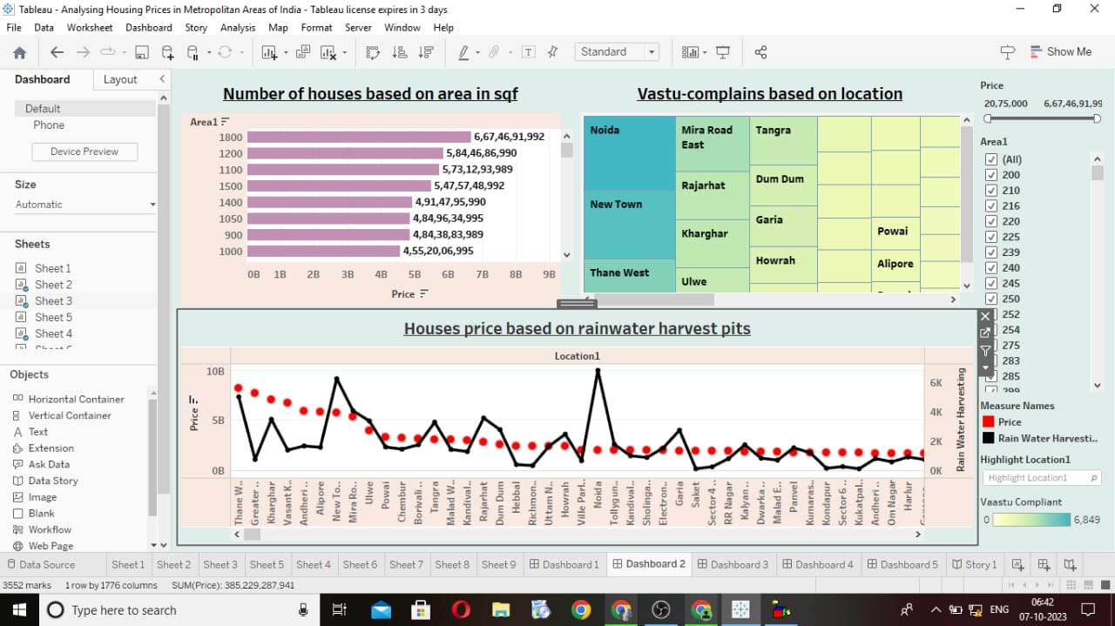

**Dashboard 5 :**

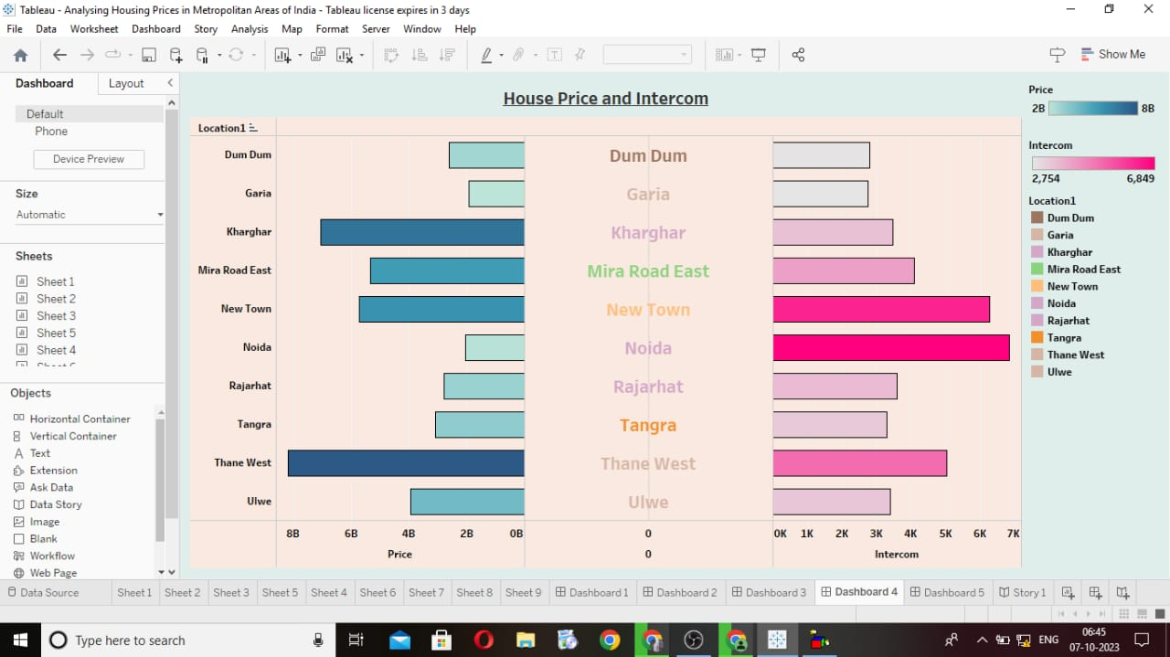

**Story 1 :**

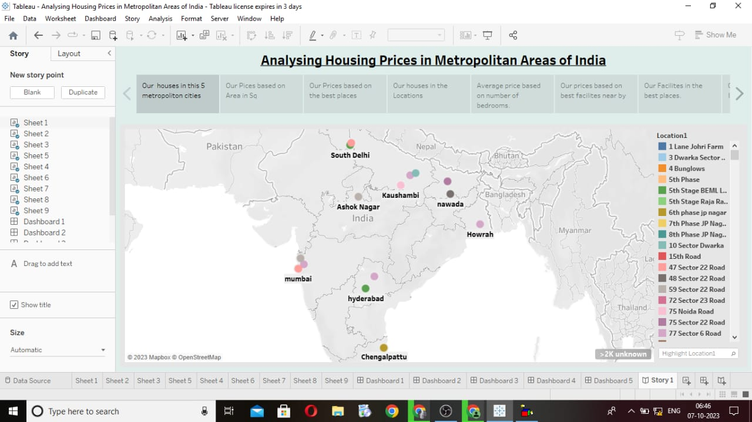

**Story 2 :**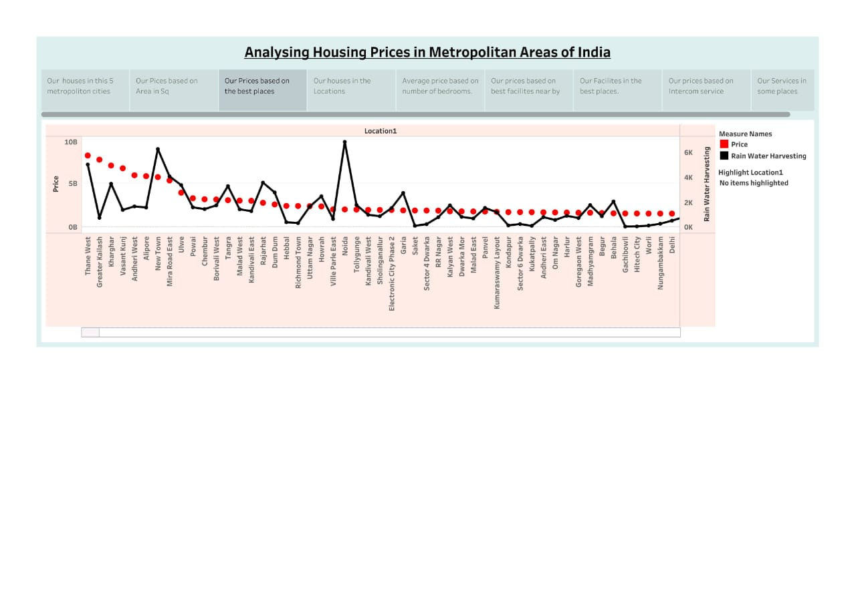

**Story 3**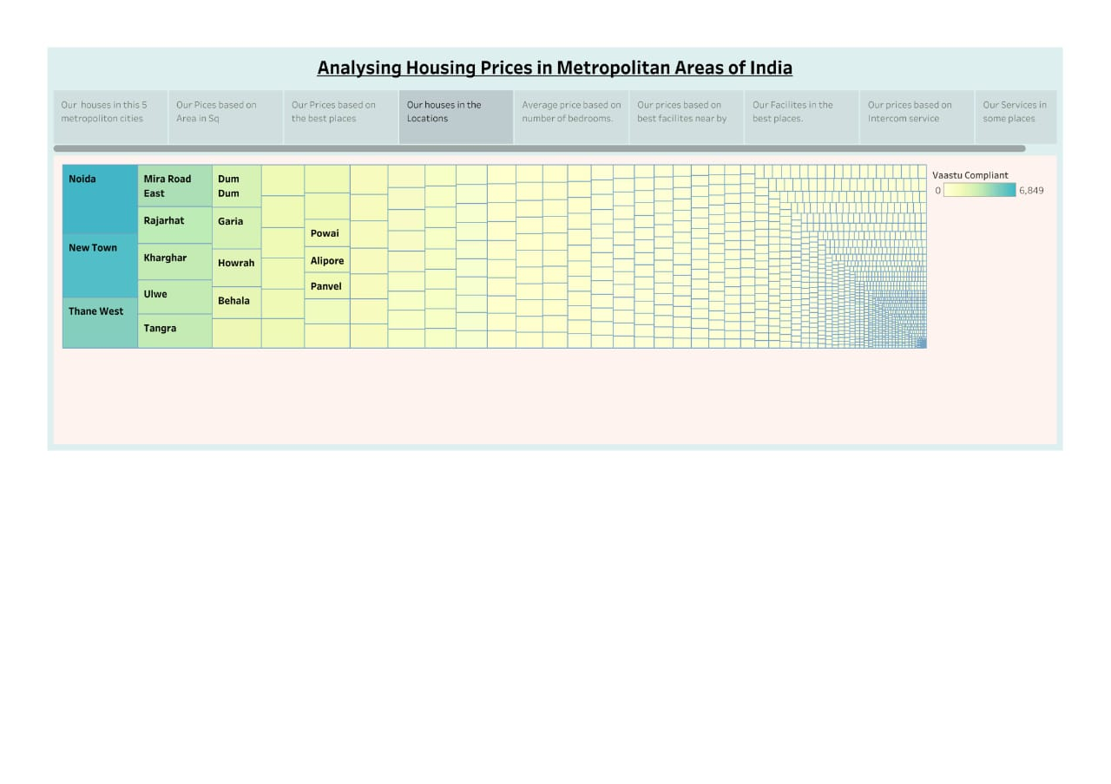

**Story 4 :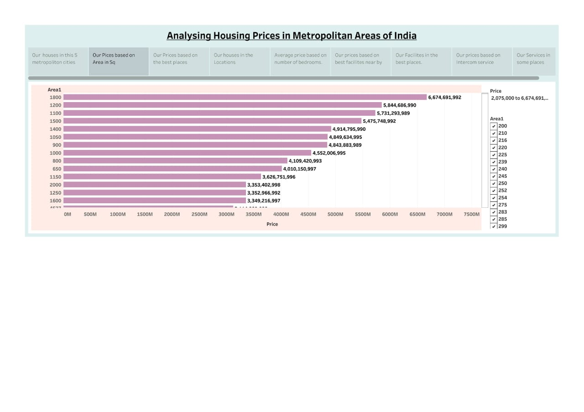Story 5 :**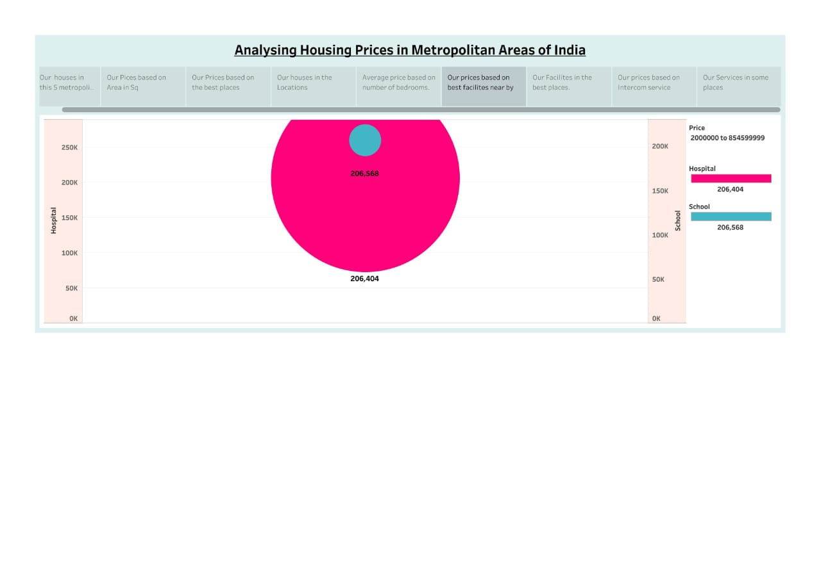

**Story 6 :**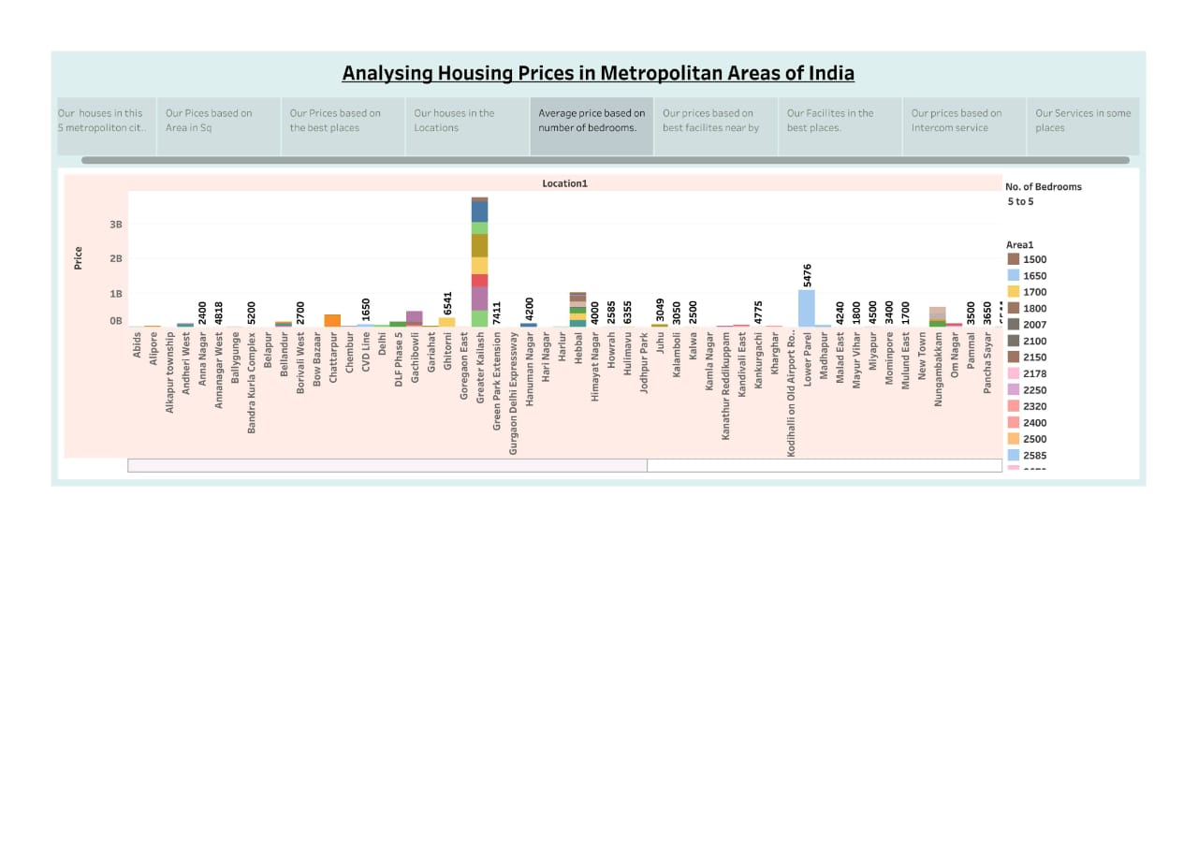

**Story 7 :**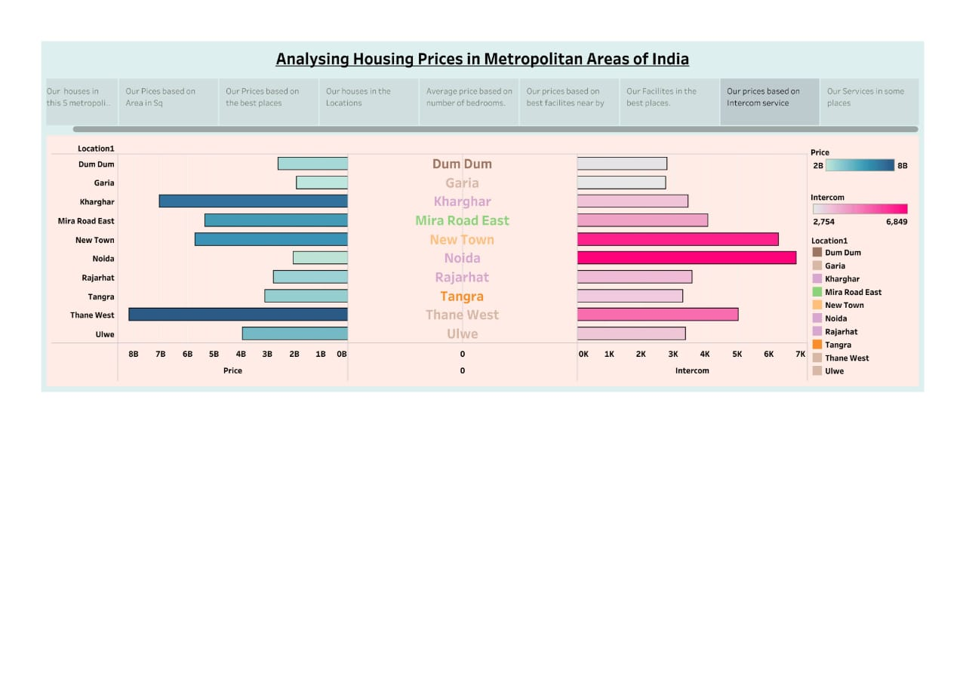

**Story 8 :**

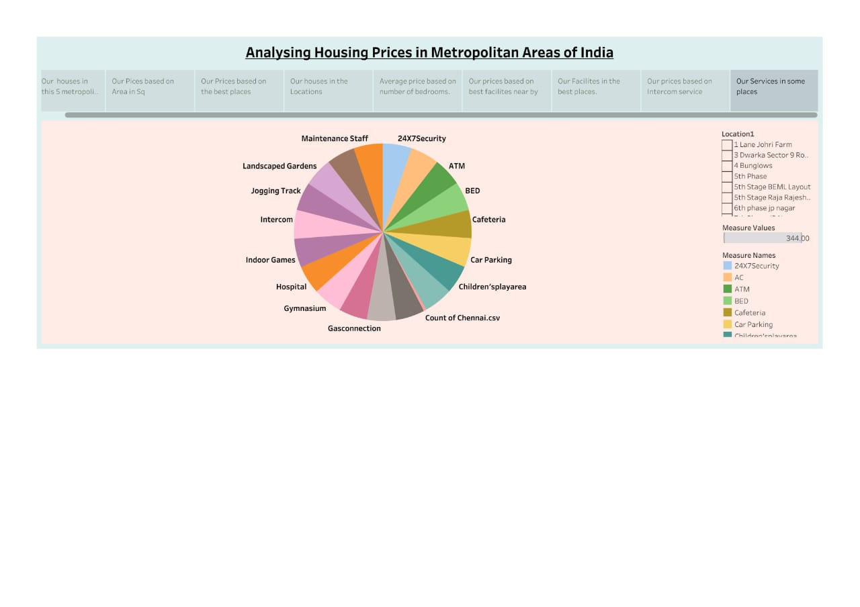

**Story 9 :**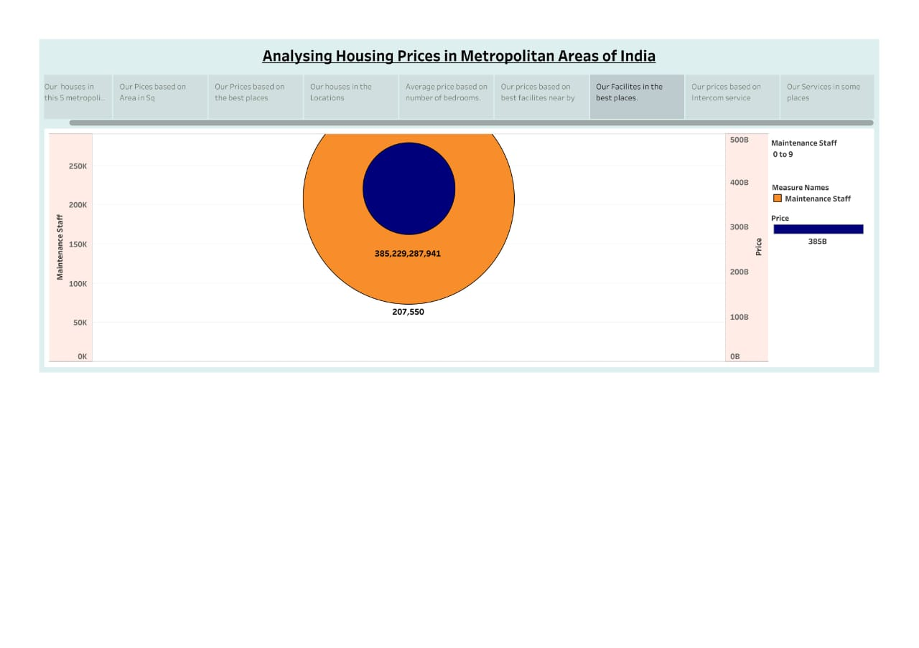

**4. ADVANTAGES & DISADVANTAGES :**

**Advantages :**

Informed Decision-Making:

It provides valuable information to various stakeholders, such as investors, homebuyers, and developers, enabling them to make well-informed decisions in the real estate market.

Market Insights:

By studying housing price trends, individuals and organizations can gain insights into the dynamics of the real estate market, helping them identify opportunities and potential risks.

Location Selection:

Homebuyers can use this analysis to find areas that match their budget, preferences, and lifestyle, allowing them to choose the best location for their needs.

**Disadvantages :**

Data Quality Issues:

Housing price data may be incomplete, inaccurate, or outdated, which can lead to unreliable analysis and decision-making.

Market Volatility:

Real estate markets can be subject to rapid and unpredictable changes, making it difficult to accurately predict future price trends.

External Factors:

Housing prices are influenced by a wide range of external factors, including economic conditions.

**5. APPLICATIONS :**

Environmental Impact Assessment:

Analyzing housing prices can provide insights into how urbanization and development impact the environment and natural resources, assisting in sustainable planning**.**

Transport and Infrastructure Planning:

Transportation authorities can use housing price data to plan public transportation routes and road infrastructure to cater to areas with high housing demand.

These applications highlight the wide-ranging significance of housing price analysis in decision-making, investment, and policy development in metropolitan areas of India and other regions.

**6. CONCLUSION :**

In conclusion, analyzing housing prices in metropolitan areas of India is a multifaceted and dynamic process with significant implications for a wide range of stakeholders. This analysis serves as a valuable tool for making informed decisions, investments, and policies in the real estate sector.

The advantages of such analysis include informed decision-making, market insights, location selection, and efficient resource allocation, among others. Ultimately, analyzing housing prices is a valuable tool that aids in understanding and navigating the dynamic real estate market market in metropolitan areas of India and will continue to be essential for stakeholders in the years to come.

**7. FUTURE SCOPE :**

The future scope of housing price analysis is promising, with advancements in data analytics, technology, and changing market dynamics.

This evolving landscape will provide new opportunities and challenges for those involved in the real estate market.

Alternative Housing Models:

The rise of co-living, co-working spaces, and other alternative housing models may require new analytical approaches to understand their impact on traditional housing prices.

Government Initiatives:

Government programs related to affordable housing and urban development will continue to shape the housing market, and analysis will need to consider the effects of such initiatives.

Economic and Geopolitical Factors:

Housing prices can be influenced by broader economic and geopolitical trends. Future analysis will need to account for these factors.

Virtual Reality and Augmented Reality:

Virtual reality and augmented reality technologies may play a role in property viewing and marketing, potentially affecting housing prices.

**8. APPENDIX A :**

**Source Code :**

